**Go Directly to Jail: DS-6014 Final Project**

**Problem Description**

We plan to find the probabilities of landing on every square on the board square regardless of where a player starts as a function of the number of sides of each die, n, and the number of doubles one would need to roll before going to jail, s. Given these probabilities we will calculate the expected income of every property on the board for every level they could be improved, and the number of opposition rolls needed before the owner of the property earned back the money they spent on said property. Using these values for return on investment on a property, we want to amend the game such that jail space can be owned like any other utility or railroad with the following assumptions; it cannot be improved but can collect rent, the rent is equal to the average per day expense of imprisoning someone in America, the lot price of jail is competitive with other properties such that the number of opposition rolls needed for a player to recoup their investment in jail was on par with other unimproved properties.

**Bayesian Methodology**

Using Bayesian methods, we accounted for the uncertainty associated with the change in a player’s position on the board after a turn introduced by the dice as well as the chance and community chest cards and how the player chose to leave jail. While such a problem would lend itself to sampling very well by placing a uniform prior on the probability of visiting every square on the board and simulating a token rounding the board over hundreds of thousands of turns, we elected to derive the probabilities landing on every square as a function of the number of sides of each die and the number of doubles one would need to roll before going to jail. This approach would result in transition matrices of a Markov Chain which via QR decomposition would yield a distribution of the probabilities of landing on each space on the board identical to the posterior distribution of the aforementioned sampling estimate would estimate.

**Mathematical Linkage and Approach**

This aspect of the game can be modeled as a Markov Chain with the current state a player occupies is represented by the square they start their turn from, and the subsequent state is the square where they end their turn. Where the probabilities that populate this matrix is the sum of the probabilities of rolling to the space a player will end their turn, the product of probability of rolling to a chance or community chest card and the chance of drawing a card that would direct a player to the space they will end their turn and in the case of jail, the probability of speeding.

Using distributions which modeled how far a player will advance based on the set of dice rolls comprising their turn, we calculated the likelihood of rolling to every property on the board as a function of the based solely on the space from which their turn began. The uncertainty of how a player would choose to leave jail was accounted for by using two different distributions to model how far a player will advance when their turn starts in Jail. Lastly, the uncertainty introduced by the chance and community chest spaces were then taken into account by reducing the probability of landing on those squares by the probability those spaces would yield a card that would augment the player’s position and increasing the probability of landing on those properties a player would be redirected to by the same amount.

Given the number of sides of the dice, n, and the number of doubles rolls needed before a player is sent to jail, s, we hope to find the probabilities of landing on a given space on the board regardless of where a player's turn starts. As specified in Monopoly's rule book, a player must roll their dice again if the faces of both dice are equal to one another and rent is paid for, or a chance or community chest card is drawn from the space they end their turn. This rule allows us to model the how far a player will advance on a given turn by generating all n2s possible rolls and summing all of the die faces of all the allowed rolls. (ie. a player would advanced 20 spaces for the following combination of possible dice rolls [5, 5, 6, 4, 3, 1] since the final pair of dice would not be have been rolled because the previous pair of die faces did not match and thus wouldn't be included in the sum). Monopoly rules also specify that a player must go directly to jail if they roll three doubles in a row, for what is known as speeding. The probability of a player going to jail for speeding is represented in Figure 1, by their chance of advancing 0 spaces, as it is impossible for the faces of two die to sum to zero.

When in jail, a player can either choose to use a "Get Out of Jail Free" card or pay a $50 fee and advance from jail like it is any other space on the board, or exit by rolling doubles in one of their following three turns. If they fail to do so they will be released on their third turn. The later can be advantageous to the player because while in jail a player can still collect rents, and bid on or improve properties all while avoiding paying rent as their opponents improve their properties and increase their rents. If a player decides to leave via dice roll, they do not get to roll again in the event the roll doubles even if it is on their final turn in jail. In our analysis, we assumed the maximum number of turns a player could spend jail was equal to the number of doubles a player would need to roll to be sent to jail for speeding, s. The probability of a player seeing their ith turn in jail can be modeled by pi = (n-1)i-1/ni-1 where i ≤ s. Again, the probability of a player going to jail for speeding is represented below by their chance of advancing 0 spaces.

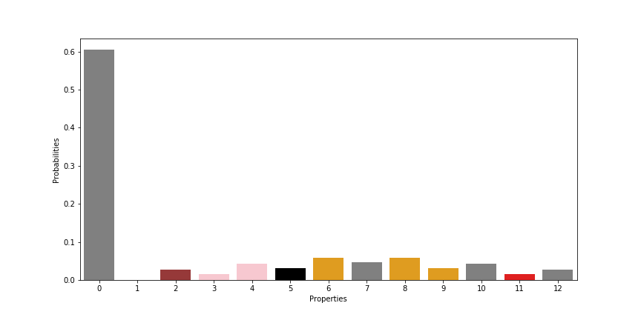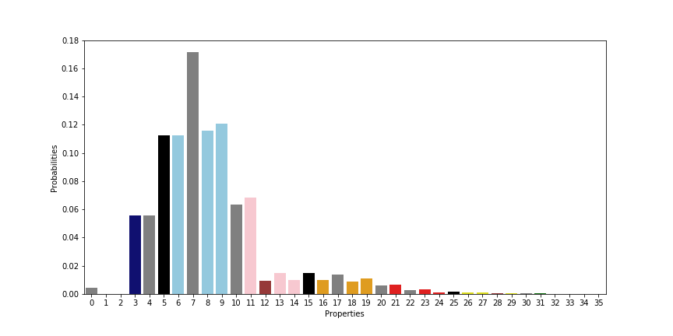

*Figure1 - Probability of Advancing i Spaces in One Turn*  *Figure2 - Probability of Advancing i Spaces Having Started in Jail*

When in jail a player can either choose to use a "Get Out of Jail Free" card or pay a 50 dollar fee and advance from jail like it is any other space on the board, or exit by rolling doubles in one of their following three turns should they fail to do so they will be released on their third turn. The later can be advantageous to the player because while in jail a player can still collect rents, and bid on or improve properties all while avoiding paying rent as their opponents improve their properties and increase their rents. If a player decides to leave via dice roll, they do not get to roll again in the event the roll doubles even if it is on their final turn in jail. In our analysis, we assumed the maximum number of turns a player could spend jail was equal to the number of doubles a player would need to roll to be sent to jail for speeding, s. The probability of a player seeing their ith turn in jail can be modeled by pi = (n-1)i-1/ni-1 where i ≤ s. Again, the probability of a player going to jail for speeding is represented below by their chance of advancing 0 spaces.

Using the probability distribution of advancing from one square to another along with the probability distribution of advancing from jail, we can produce two transition matrices which describe the probability of a player landing on space j given they started at space i, seeking to either minimize their stay in jail or maximize it. These transition matrices can be represented via a network graph. Almost every space is reachable from almost every other space in just one turn for a standard game of monopoly, n = 6 and s = 3.

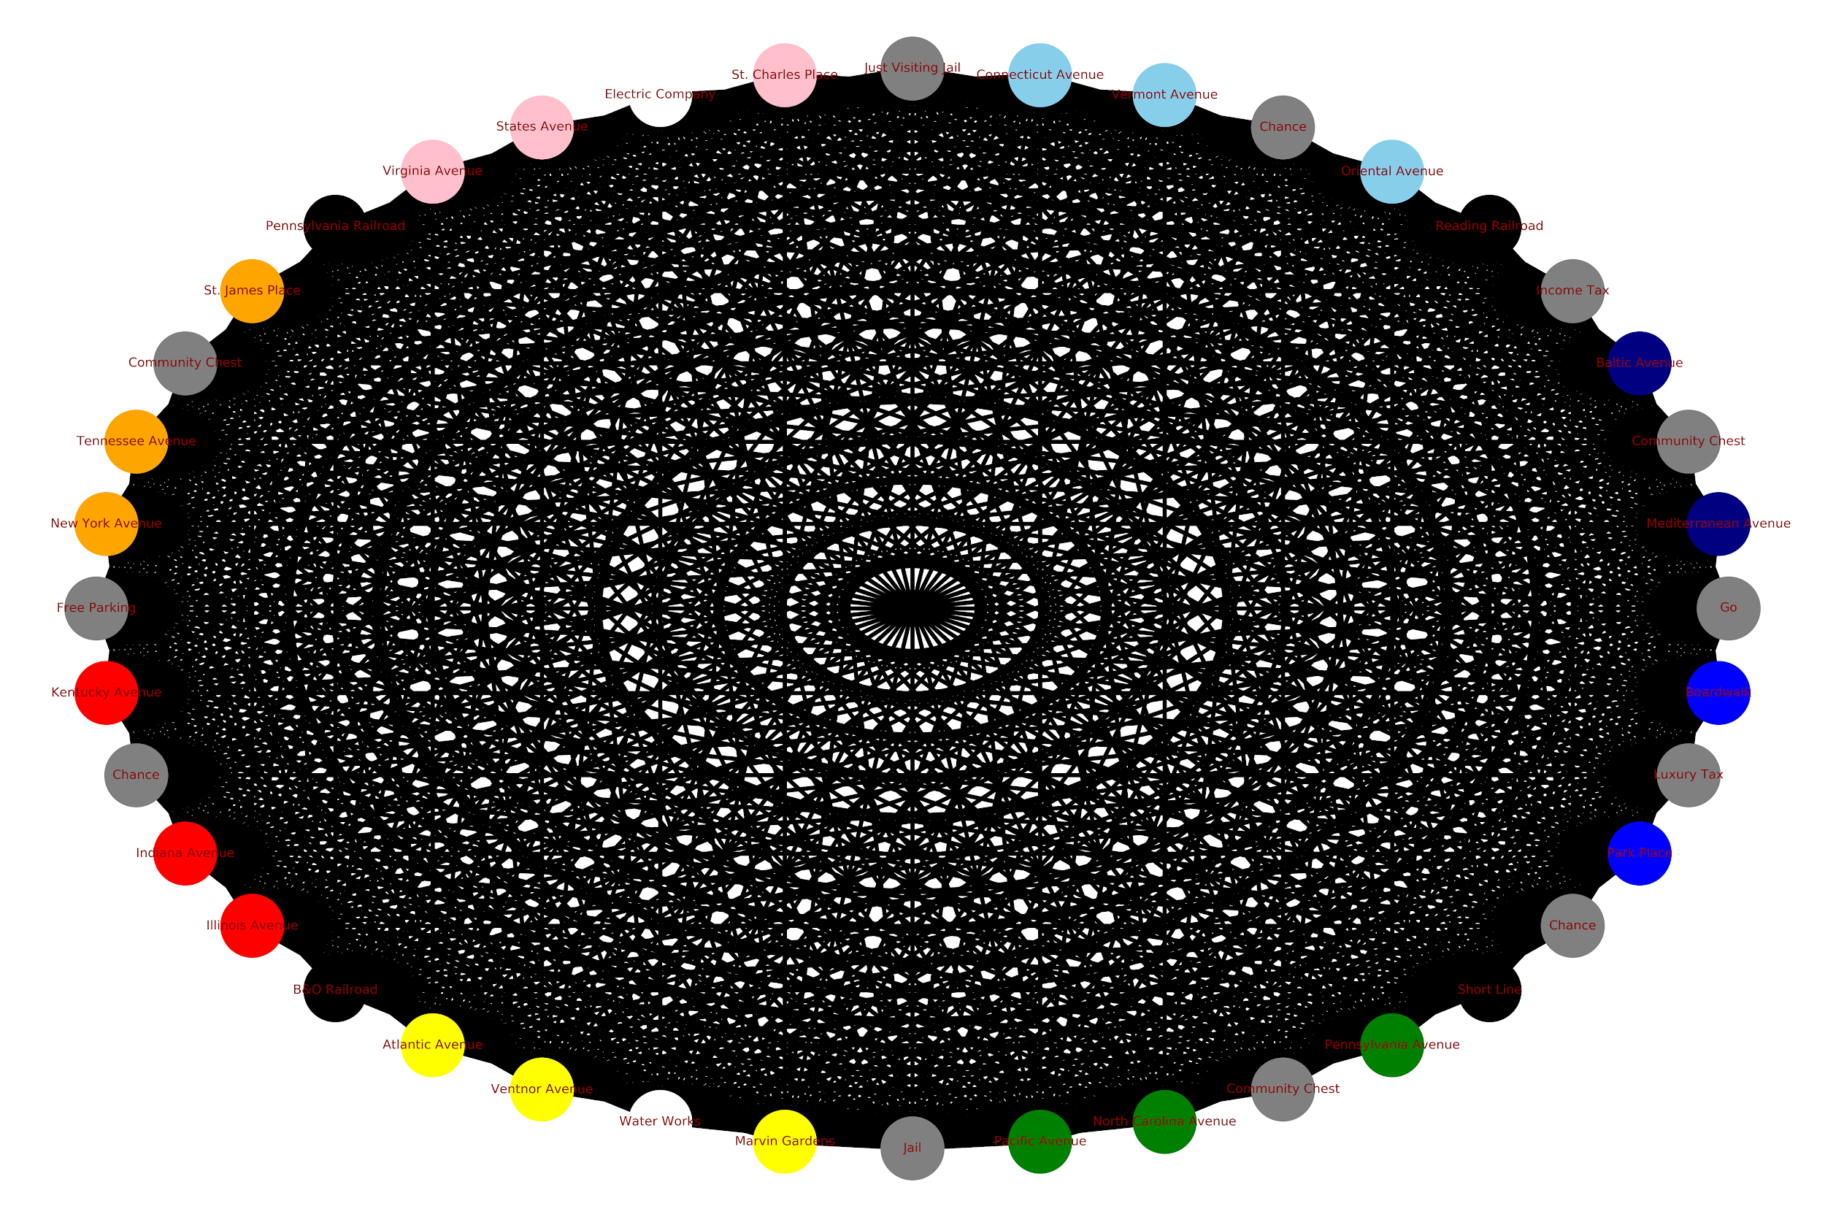

*Figure3 - Graphical Representation of the Transition Matrices*

Chance and Community Chest spaces both contain cards which augment the probabilities of landing on particular spaces via cards which instruct the player who draws them to advance to a particular property. These augmentations to the landing probabilities can be represented graphically but differences between these graphs and their counterparts above are hard to perceive visually as each are very well connected and most of the changes are to the weights links.

**Result & Conclusion**

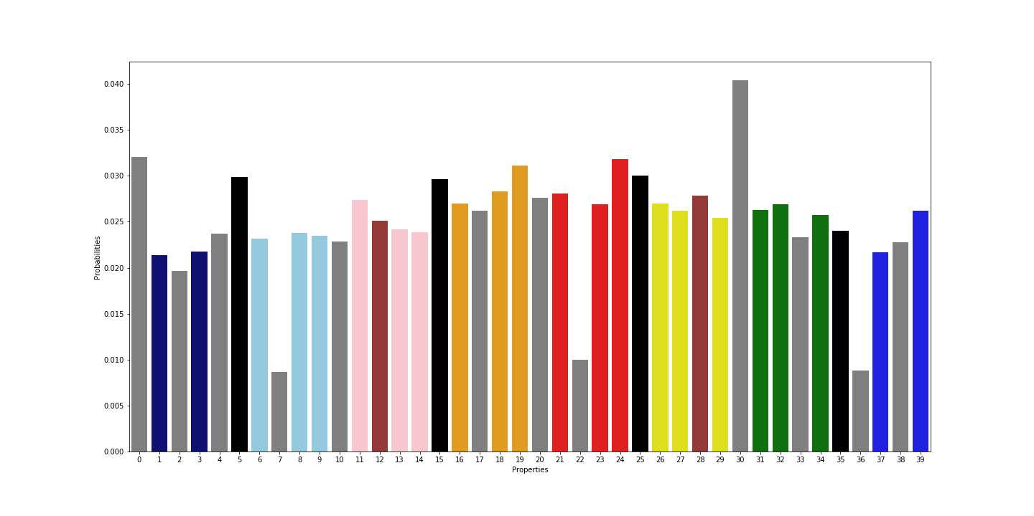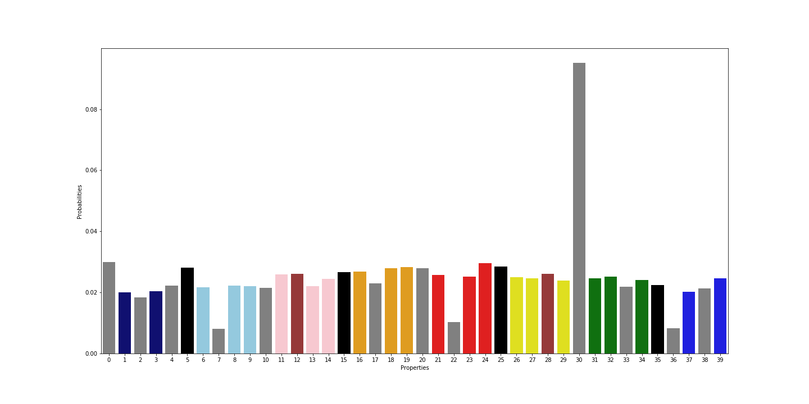

*Figure4 - Steady State Landing Probabilities for a player Figure5 - Steady State Landing Probabilities for a player f Minimizing their Time in Jail Maximizing their Time in Jail*

As a result of transition matrices, we got the landing probabilities on properties. The Figure 4 is a plot of these probabilities for players who intends to spend as little time in jail as possible shows that jail is still the space they occupy most frequently, this is likely due to the fact that there are 4 ways to wind up in jail in monopoly with the first being speeding, followed by drawing a chance card the directs one to jail, a community chest card which does the same, and landing on the 30th space on the board which is “Go to jail”. As a result the most frequented properties are those belonging to the red and orange suites, led by Illinois and New York Avenue's respectively. Properties in the yellow and pink suite also receiving a marginal benefit for being located between the Jail and "Go to Jail" spaces.

The Figure 5 shows the probabilities of landing on property for long stay in jail. We all pay the price of high incarceration rate; as players elect to maximize their time in jail, the probabilities of any given turn ending with a player in jail increases, with the probability of said outcome increasing from 4% to 9%. What is surprising is that this change in strategy appears to have affected all other properties relatively equally, with the ordering of spaces by landing probability changing marginally.

With the probabilities of landing on each space, we can now calculate the expected income of every property for every level of improvement and expected number of opponent rolls to recoup one's investment for both strategies. As specified in Monopoly’s rule book, the difference between the most and least improved property in a suite cannot exceed one house. Meaning the marginal cost of building a second house on a property is not only the cost of building said house but the cost of building a house on every other property in the suite. And the income the owner of said property can expect is at least equal to the expected rent of the property at said state of improvement and the sum of the expected rents of the other properties in the suite with one fewer house erected, since the owner of the improved property also maintains the other properties in the suite with at most one fewer house. The number of opposition rolls needed before the owner of a property in a given state of improvement recoup their investment is the quotient of the total cost of improving a property to that state and the expected income of that property in that state.

*Figure6 - Log of Expected Number of Turns by Opposing Players Figure7 - Log of Expected Number of Turns by Opposing Players who who Minimize their time in Jail by the property’s who Maximize their time in Jail by the property’s has been improved level of improvement level of improvement*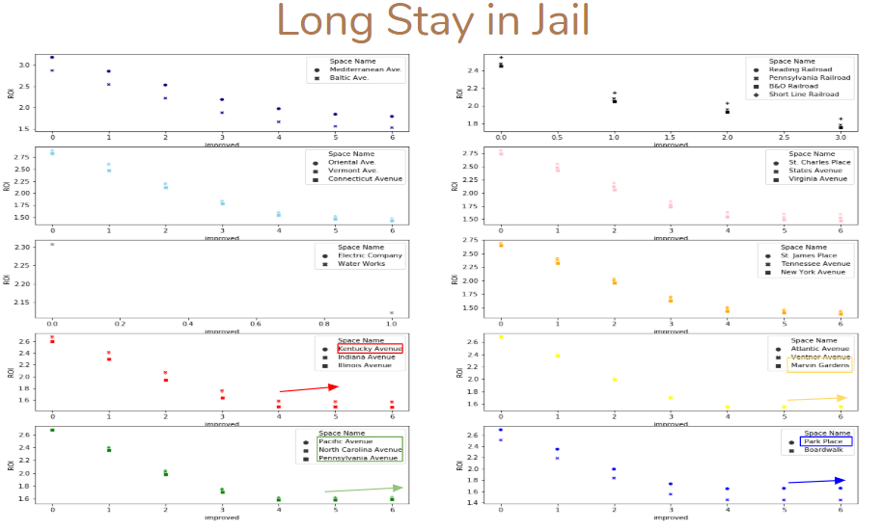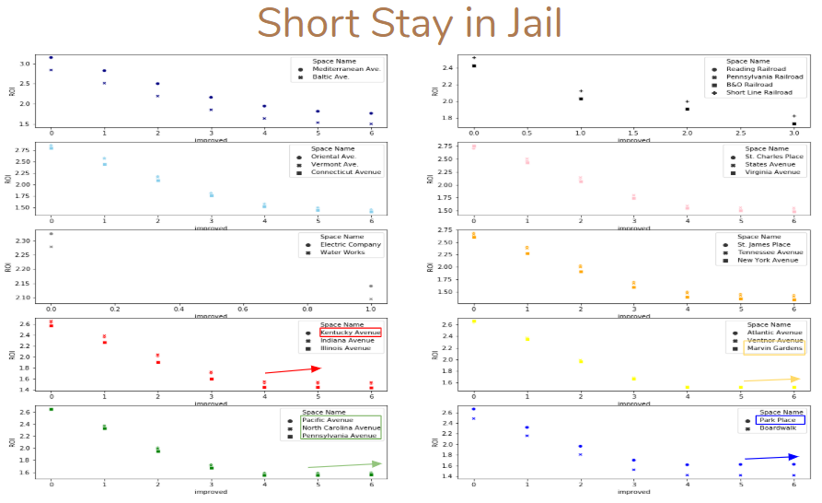

When plotting the log of the number of opposition rolls needed to break even against level of improvement we see that in the more a property can be improved the quicker a player can earn back their investment. This means that conventional properties upon which houses and hotels can be built offer much better returns that railroads and utilities. For these properties we see that while a player can expect to wait a long time before recouping the cost of purchasing an unimproved property, those number of opposing player rolls to break even drop very quickly for the first house built, so much so that this data has to be represented on graphs with a logarithmic scale. Perhaps the most interesting information conveyed in these plots is that for certain suites of properties the number of rolls needed to recover the cost of improving a property to a given state reaches a minimum, usually at three houses, and players who further improve properties in these suites can expect to wait longer to break even.

|  |  |  |  |
| --- | --- | --- | --- |
|  | Unimproved ROI | Average Rent | Estimated Price |
| Max | 1502 | 91 | 13012 |
| Mean | 507 | 91 | 4392 |
| Min | 202 | 91 | 1752 |

*Figure8 - Suggested Lot Prices of Jail*

We wanted to make jail property on the board that players can own, and charge opposing players’ rents for their time there. We determine the rent based on how much it cost to imprison someone in america for one day. We assume the jail space cannot be improved upon as such we compared it to the expected number of opposition rolls of other properties in an unimproved state. Using the minimum, mean, and maximum of those values along with the steady state probability of a turn ending in jail for those who lack the opportunity to be released from jail as soon as they arrive to determine the lot price of Jail.

**Work Cited**

*Probabilities in the Game of Monopoly&Reg*, <http://www.tkcs-collins.com/truman/monopoly/monopoly.shtml>.

“Vera Institute.” *Vera*, 8 Dec. 2019, https://www.vera.org/publications/price-of-prisons-2015-state-spending-trends/price-of-prisons-2015-state-spending-trends/price-of-prisons-2015-state-spending-trends-prison-spending.